

Testing - Admin



Admin Portal – If login for admin successful

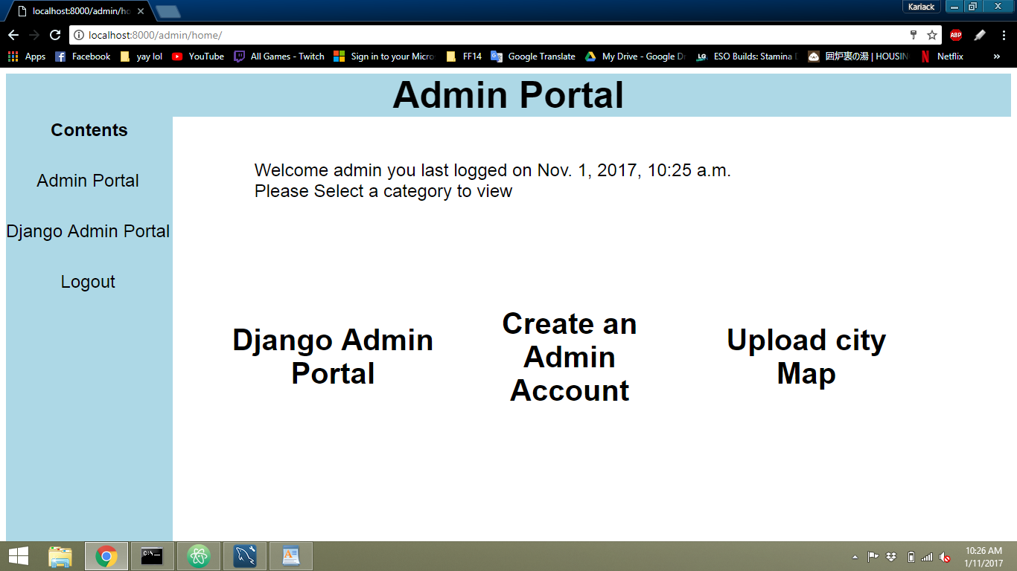

Admin Portal – When Django Admin portal is selected



Screen goes to

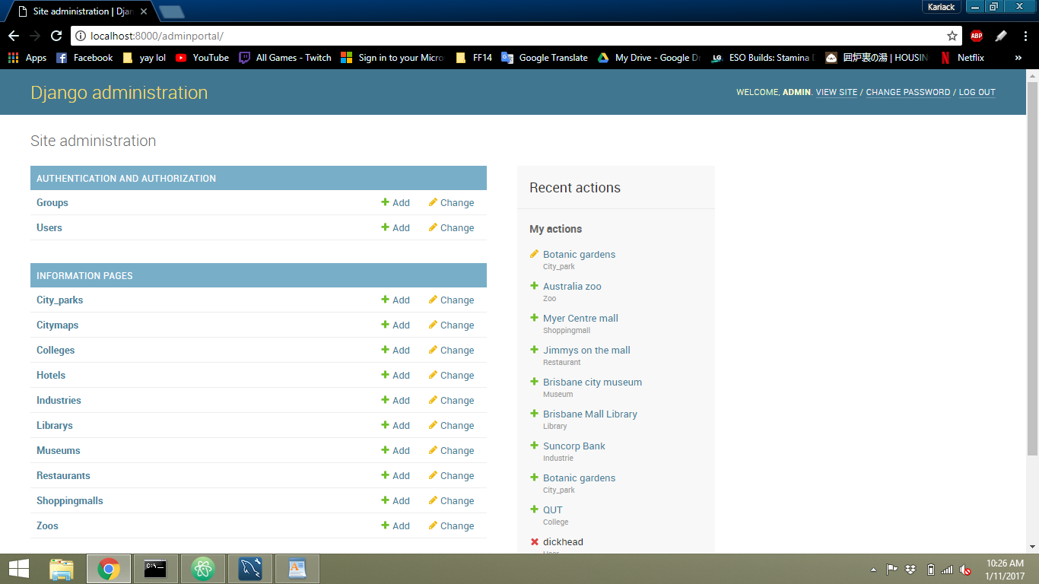

Admin Portal – When create an admin account is selected

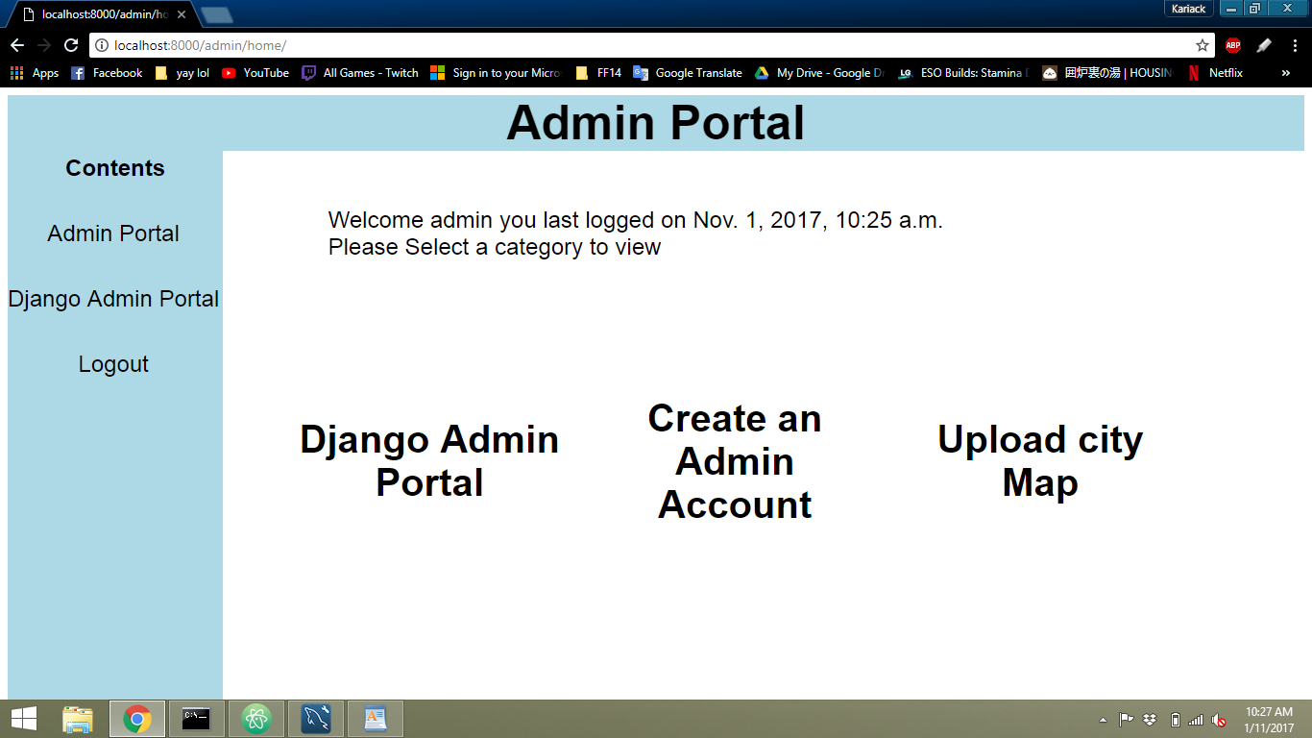

Screen goes to

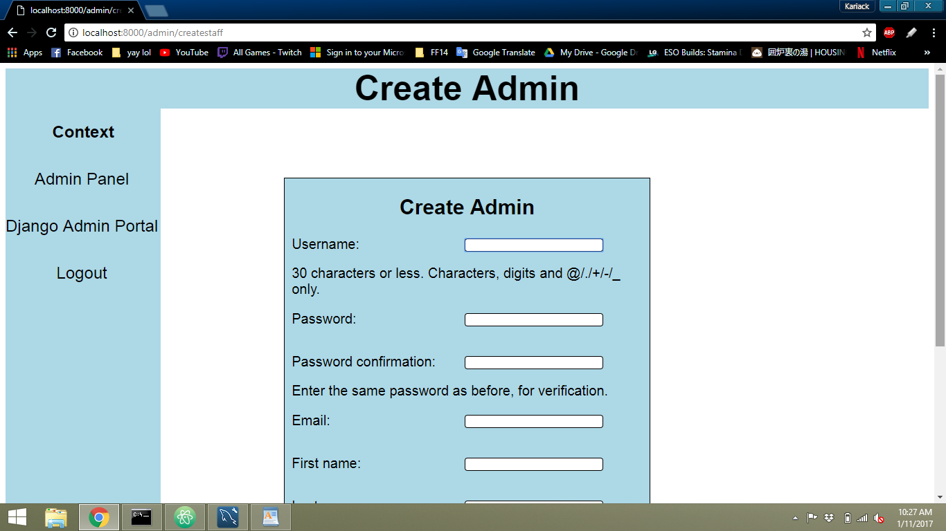

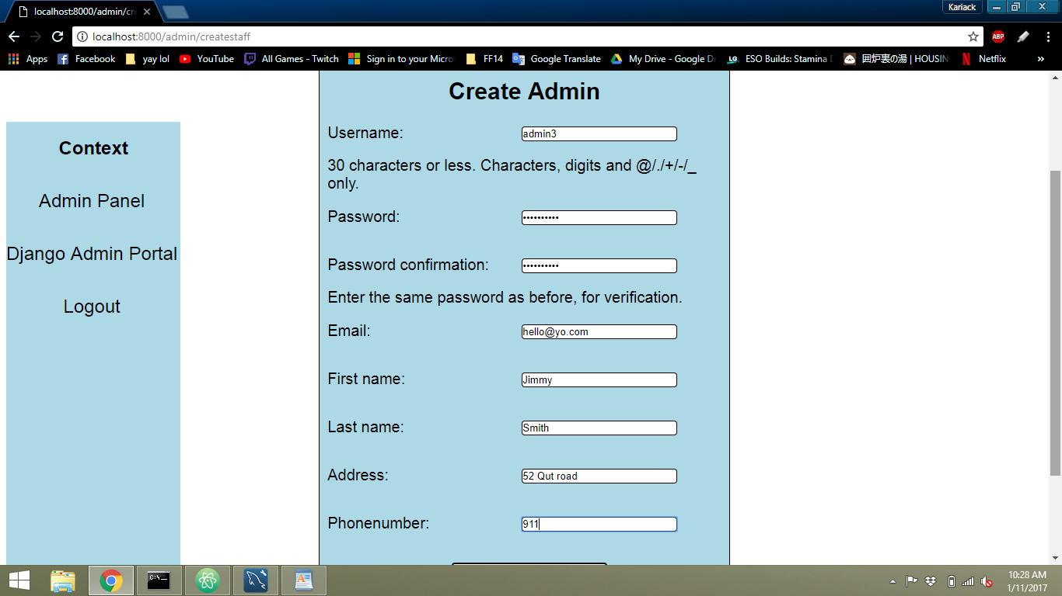When correct details are entered to the create admin form

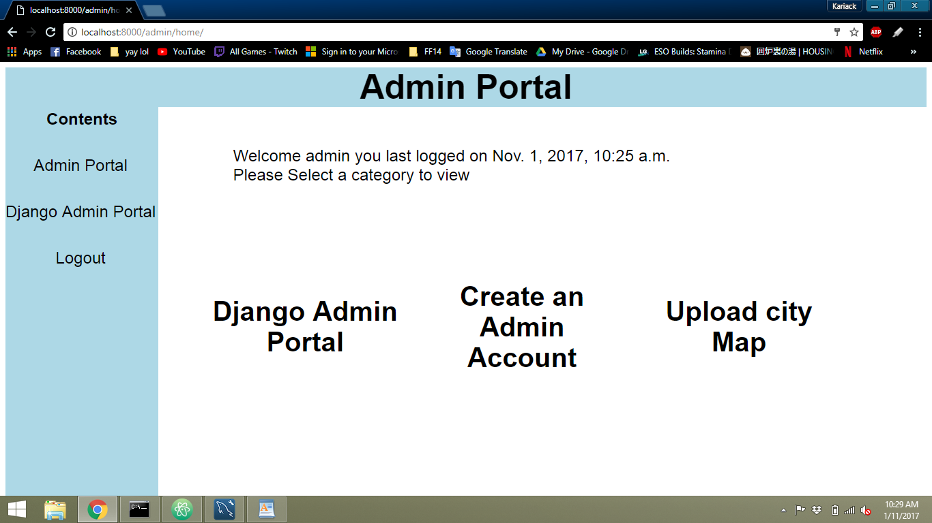Screen goes to

When details are not entered, HTML5 validation kicks in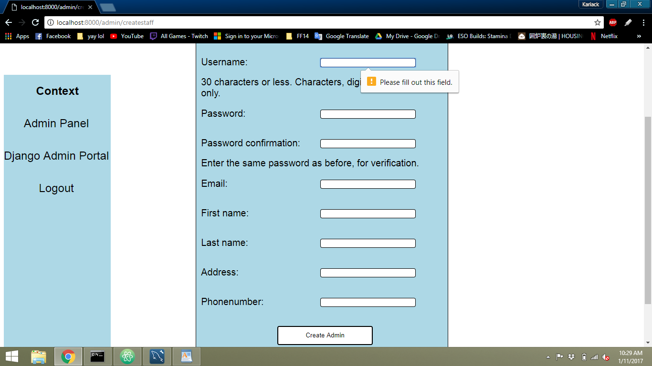

When entered incorrectly

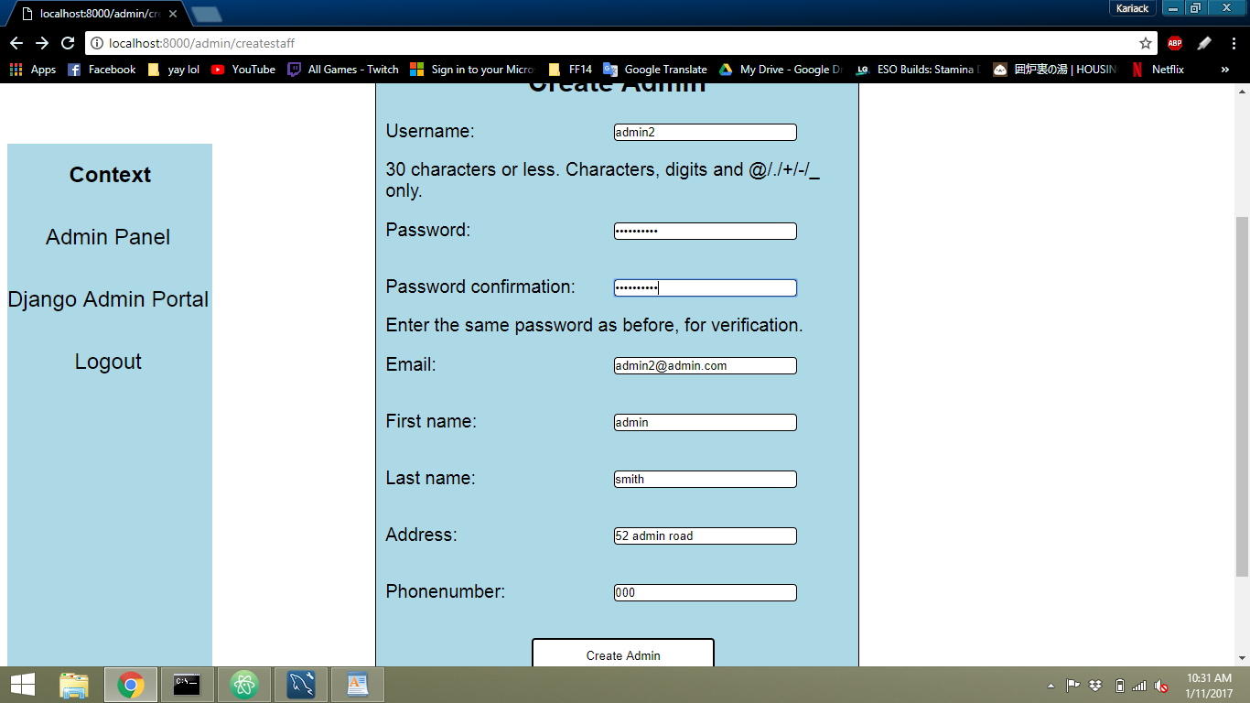

Error message appear

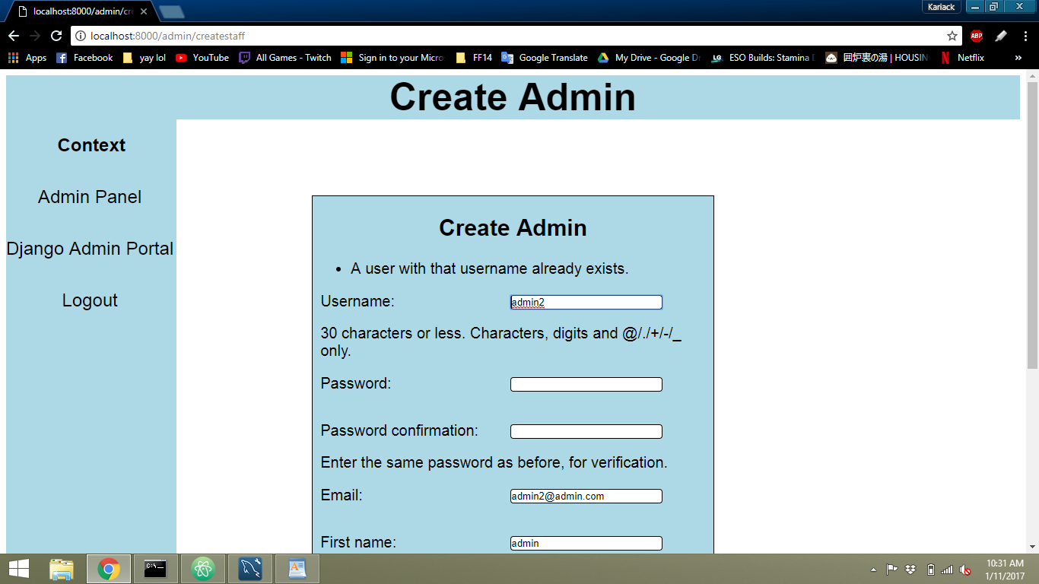

Admin portal – When upload city map is selected

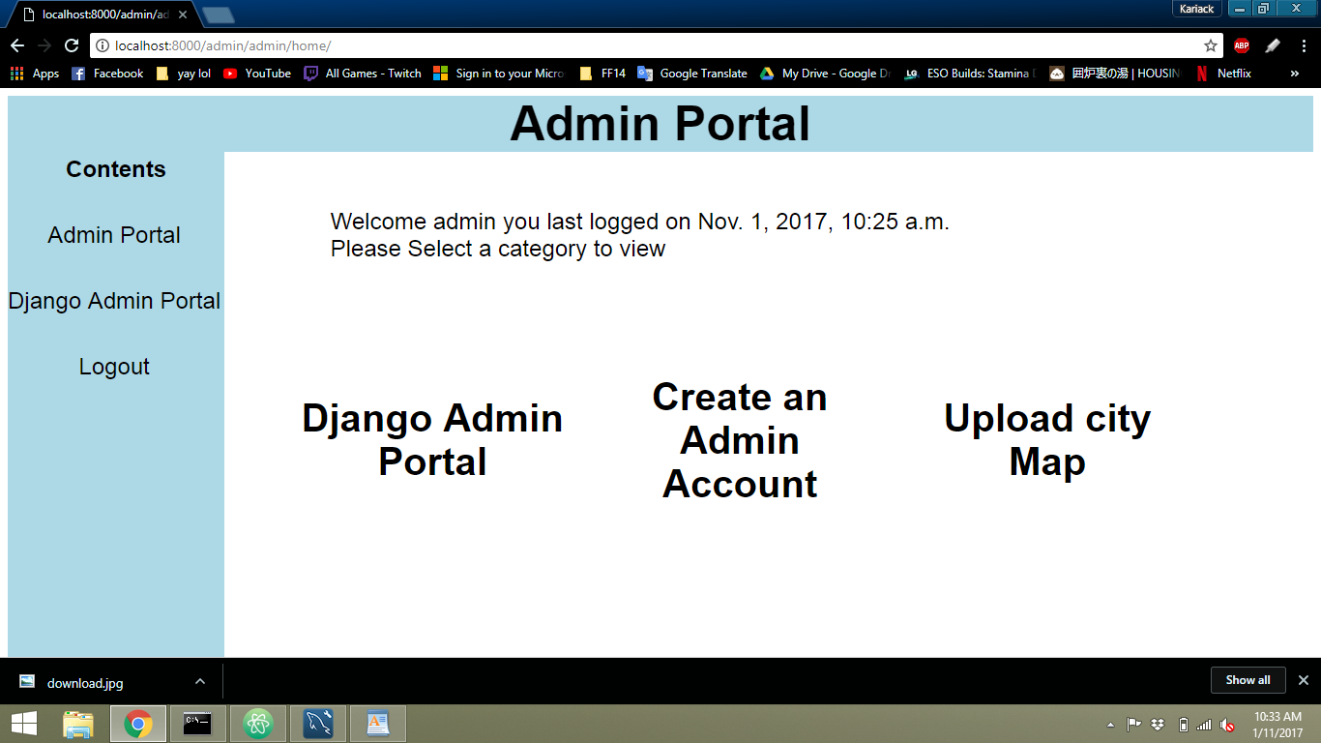

This form is returned

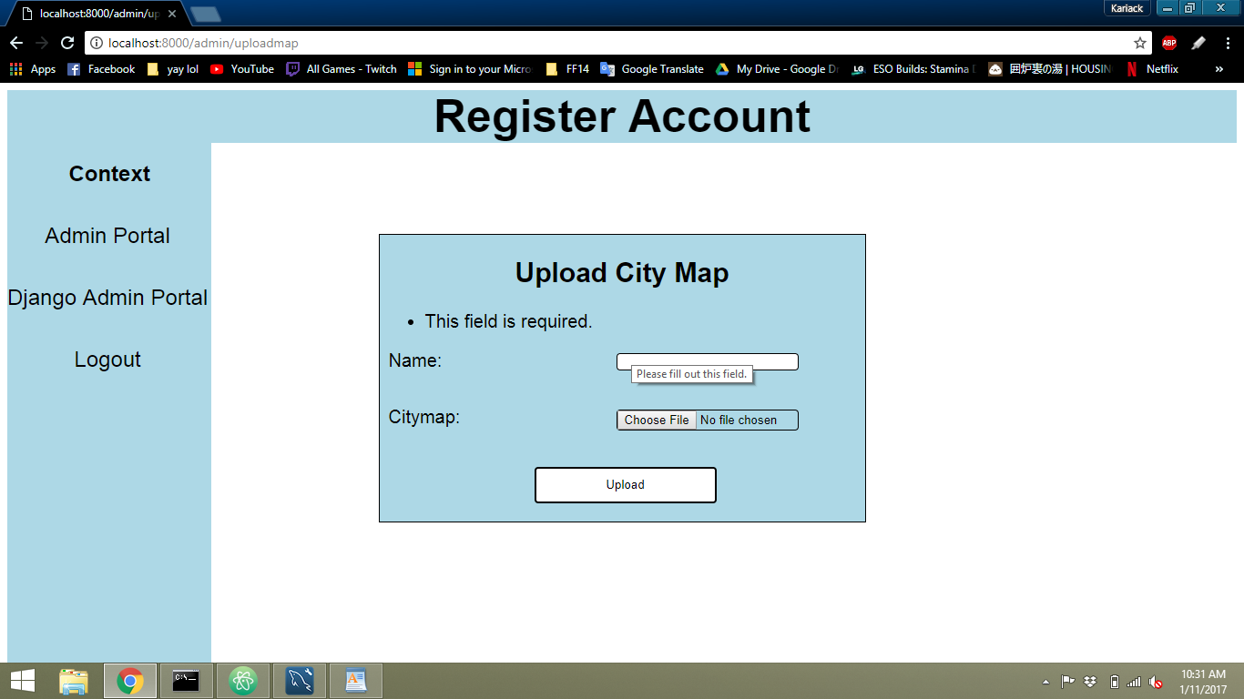

If details and a file are uploaded

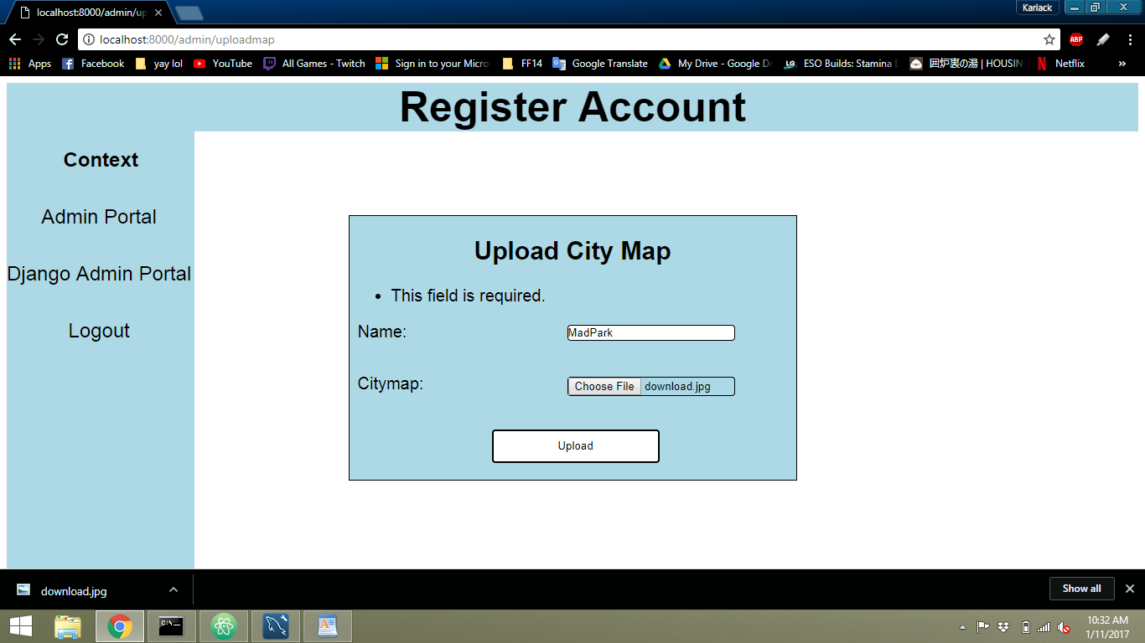

This screen is returned



If the users presses the logout



The user is logged out and this is returned

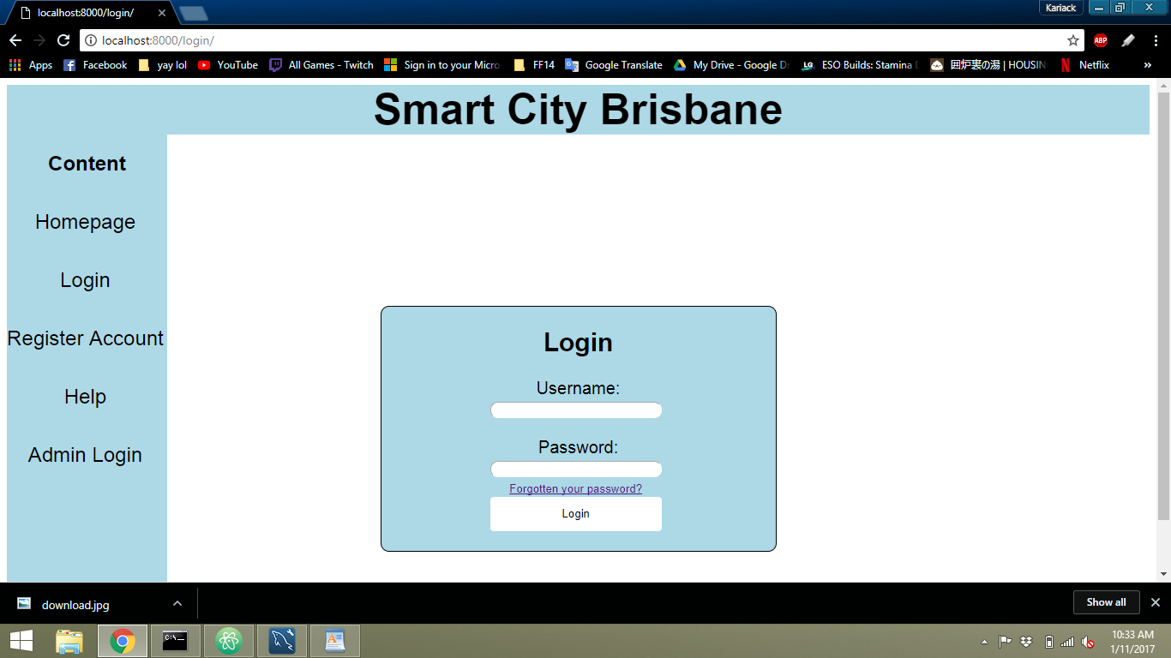

If in any page, that is not the admin portal, and the user presses admin portal



Then this page is returned



**Results**

|  |  |  |  |  |  |  |  |
| --- | --- | --- | --- | --- | --- | --- | --- |
| Serial Number | Test case description | Entry criteria | Exit criteria | Expected result | Actual result | Test date | Test pass/fail |
| 001 | Test if **Django admin portal link** works in admin portal | Django admin portal link exists on page | Re-directs to the Django admin portal | It will re-direct to the Django admin panel when clicked. | Leads directly to the Django admin portal, both links work. | 30/10/17 | Pass |

|  |  |  |  |  |  |  |  |
| --- | --- | --- | --- | --- | --- | --- | --- |
| Serial Number | Test case description | Entry criteria | Exit criteria | Expected result | Actual result | Test date | Test pass/fail |
| 002 | Test if **Create an admin account** works for admin portal | Admin entry link present. Admin account registration form completed | Re-directs to the create an admin page | It will re-direct to the create admin when it’s clicked. | Redirected to the create admin form | 30/10/17 | pass |

|  |  |  |  |  |  |  |  |
| --- | --- | --- | --- | --- | --- | --- | --- |
| Serial Number | Test case description | Entry criteria | Exit criteria | Expected result | Actual result | Test date | Test pass/fail |
| 003 | Test if **create admin** **form** works | Create admin form exists and validates | Admin is successfully created and added to database | It will create admin account the redirect to admin portal | Admin account was created. Redirected to admin portal | 30/10/17 | pass |

|  |  |  |  |  |  |  |  |
| --- | --- | --- | --- | --- | --- | --- | --- |
| Serial Number | Test case description | Entry criteria | Exit criteria | Expected result | Actual result | Test date | Test pass/fail |
| 004 | Test if **create admin validation** works | Create admin form created | Account is not made. No redirect | Will return an error and reason of error | When incorrect details where entered the form returned an error. | 30/10/17 | pass |

|  |  |  |  |  |  |  |  |
| --- | --- | --- | --- | --- | --- | --- | --- |
| Serial Number | Test case description | Entry criteria | Exit criteria | Expected result | Actual result | Test date | Test pass/fail |
| 005 | Test if **upload city map** works in admin portal | Upload city map link exists. | Re-directs to the upload city map form | Will re-direct to upload city map page | Did redirect to page successfully | 30/10/17 | pass |

|  |  |  |  |  |  |  |  |
| --- | --- | --- | --- | --- | --- | --- | --- |
| Serial Number | Test case description | Entry criteria | Exit criteria | Expected result | Actual result | Test date | Test pass/fail |
| 006 | Test if **upload map** works | Map added to database | Re-directs to admin portal | Map added to database, redirect to admin portal | Map successfully added. Re-direct success | 30/10/17 | pass |

|  |  |  |  |  |  |  |  |
| --- | --- | --- | --- | --- | --- | --- | --- |
| Serial Number | Test case description | Entry criteria | Exit criteria | Expected result | Actual result | Test date | Test pass/fail |
| 007 | Test **Logout** button works | logout out button exists | Signs out user and re-directs to home page | The user will be signed out and the user will be directed into the home page |  |  |  |

|  |  |  |  |  |  |  |  |
| --- | --- | --- | --- | --- | --- | --- | --- |
| Serial Number | Test case description | Entry criteria | Exit criteria | Expected result | Actual result | Test date | Test pass/fail |
| 008 | Test if **sign out** button works in tourist page | Sign out button exists | Signs out user and re-directs to login page | The user will be signed out and the user will be directed into the login page | Session ended, user logged out. Re-direct to login page | 30/10/17 | pass |